Refined Detection of Knee Osteoarthritis Using Center Net with a Pixel-Wise Voting Approach

Prof. Usha Kumari V Abhishek S Ajay R

Dept of ISE Dept of ISE Dept of ISE

Acharya institute of technology Acharya institute of technology Acharya institute of technology

Affiliated to VTU, Belagavi – 590018 Affiliated to VTU, Belagavi- 590018 Affiliated to VTU, Belagavi - 590018

Bengaluru - 560107 Bengaluru – 560107 Bengaluru - 560107

Email: <ushakumari2487@acharya.ac.in> Email: [abhisheksshankar9@gmail.com](abhisheksshankar9@gmail.com%20) Email: <ajayrr.21.beis@acharya.ac.in>

Karnan K Asim Ulla Khan

Dept of ISE Dept of ISE

Acharya Institute of Technology Acharya Institute of Technology

Affiliated to VTU, Belagavi – 590018 Affiliated to VTU, Belagavi - 590018

Bengaluru – 560017 Bengaluru - 560017

Email: <kk.21.beis@acharya.ac.in> Email: [asims.21.beis@acharya.ac.in](asims.21.beis@acharya.ac.in%20)

**Abstract**

*This paper introduces an advanced approach for detecting Knee Osteoarthritis (OA) using an optimized CenterNet framework integrated with a pixel-wise voting strategy. Early and accurate detection of knee OA is vital for timely intervention and efficient disease management. The proposed method enhances the CenterNet architecture—a leading object detection framework—by incorporating a pixel-based voting mechanism, which leverages local image data to improve detection accuracy. Each pixel contributes to determining whether it belongs to an object or the background, and this aggregated information enables precise identification of objects and their locations. Experiments conducted on a publicly available knee OA dataset demonstrate that the proposed method outperforms existing techniques, achieving state-of-the-art results. The integration of CenterNet with the pixel-wise voting strategy holds significant promise in aiding clinicians with early diagnosis and treatment planning for knee OA patients.*

*Keywords – Knee osteoarthritis, CenterNet, Object detection, Pixel-wise voting, Medical imaging, Deep learning, Convolutional neural networks (CNN), Image analysi*

# 1.Introduction

Knee Osteoarthritis (OA) is a common musculoskeletal disorder worldwide, affecting millions and placing a significant burden on healthcare systems. The condition involves the progressive deterioration of cartilage and underlying bone within the knee joint, leading to pain, stiffness, and reduced mobility. Early detection of knee OA is crucial for effective management, as timely intervention can help alleviate symptoms and slow disease progression. However, achieving accurate and timely diagnoses often requires specialized expertise in interpreting medical images.

Traditional methods for detecting knee OA rely heavily on the manual analysis of medical images, such as X-rays and MRIs. These techniques are not only time-consuming and subjective but also demand a high level of expertise. In recent years, there has been a growing interest in developing automated computer-aided diagnosis (CAD) systems to support healthcare professionals in identifying and diagnosing knee OA. Deep learning techniques, in particular, have shown immense potential by offering more accurate and efficient detection capabilities.

Object detection is a key task in computer vision, aimed at identifying and localizing objects of interest in images. Advances in deep learning have enabled the development of highly accurate object detection models, such as CenterNet. As a cutting-edge framework, CenterNet predicts object centers and bounding boxes directly, simplifying the detection process and often improving both efficiency and accuracy. Despite its effectiveness, CenterNet may face challenges in detecting knee OA abnormalities in complex medical images with varying noise and artifacts.

To overcome these limitations, this study proposes an enhanced CenterNet framework integrated with a pixel-wise voting mechanism for detecting knee OA. This approach leverages localized image information, where each pixel contributes to determining the presence of an abnormality or background, resulting in more accurate predictions. The proposed method's performance was evaluated using a publicly available knee OA dataset and was found to surpass existing methods, achieving superior accuracy in detecting knee OA.

Accurately assessing the severity of Knee Osteoarthritis (KOA) is as important as its detection for effective treatment planning and tracking disease progression. The Kellgren-Lawrence (KL) grading system, widely adopted in clinical settings, classifies KOA severity into five grades (0 to 4) based on radiographic features such as osteophyte formation, joint space narrowing, subchondral sclerosis, and bone deformities.

* **Grade 0**: No visible radiographic signs of KOA.
* **Grade 1**: Slight joint space narrowing with potential osteophyte formation.
* **Grade 2**: Presence of definite osteophytes and possible narrowing of the joint space.
* **Grade 3**: Moderate osteophytes, significant narrowing of the joint space, some subchondral sclerosis, and possible deformity of the bone ends.
* **Grade 4**: Large osteophytes, severe narrowing of the joint space, pronounced subchondral sclerosis, and clear bone end deformities.

While the KL system remains a benchmark for grading KOA severity, manual interpretation of radiographs can be subjective and time-consuming. Automated deep learning-based grading has the potential to address these challenges by providing precise and efficient evaluations. However, due to the complexity of radiographic images and variability in disease presentation, automating severity grading continues to be a significant challenge.

This study not only focuses on detecting KOA abnormalities but also introduces a framework for automating KL grading based on these abnormalities' severity. By integrating the proposed method with the KL system, we aim to deliver a comprehensive tool that supports clinicians in diagnosis, treatment planning, and disease monitoring, ultimately improving patient outcomes.

# 2. Literature Review

Research on detecting and grading Knee Osteoarthritis (KOA) has explored various imaging modalities and techniques. Segmentation-based methods have been prominent, focusing on the precise delineation of knee structures like cartilage and bones from medical images. Deep learning architectures, including U-Net and SegNet, have achieved notable accuracy in detecting KOA through semantic segmentation.

Classification-based approaches using supervised machine learning models, such as Support Vector Machines (SVMs), Random Forests (RFs), and Artificial Neural Networks (ANNs), have also been employed to extract features and categorize KOA. Despite promising outcomes, these methods often struggle with low intensity contrast and computational inefficiencies. Deep learning techniques have shown better accuracy by leveraging features like joint space width, yet challenges such as noise and variability in radiographic images persist.

A notable study by Shaik Mahaboob Basha et al. used MobileNet with transfer learning to classify KOA severity. However, their approach achieved limited accuracy (below 72%). Another approach by Amjad Rehman et al. proposed CRK (CNN-Random Forest-K Neighbors) for feature engineering but was restricted to detection without addressing severity. More recently, İlknur Aktemur et al. introduced deep learning models for KL grading, yet their accuracy did not surpass 74%.

These limitations underline the need for more efficient, scalable methods that combine detection and severity assessment.

# 3. Methodology

This study introduces a robust framework to detect Knee Osteoarthritis (KOA) across varying severity levels using annotated regions of interest (ROI) and an optimized version of the CenterNet architecture. DenseNet-201 was chosen as the backbone for feature extraction due to its dense connectivity, which allows efficient propagation of features across layers. DenseNet captures fine details better than alternatives like ResNet by reusing low-level features.

Workflow Overview:

1. Input Data: X-ray images of knees serve as the input for the framework.
2. Feature Extraction: DenseNet-201 processes the images to generate feature maps, highlighting critical structures.
3. Detection Heads: CenterNet forms detection heads responsible for creating heatmaps, bounding box dimensions, and center offsets.
4. Knowledge Distillation: A teacher-student learning model is used to transfer knowledge, reducing computational overhead while maintaining accuracy.
5. Pixel-Wise Voting: This mechanism aggregates individual pixel contributions, generating heatmaps that precisely highlight abnormalities

1. Final Output: The model produces detailed predictions, including severity grades for knee OA based on the Kellgren-Lawrence grading system.

This method ensures efficient detection and grading of KOA abnormalities, providing clinicians with valuable insights for early diagnosis and treatment planning.

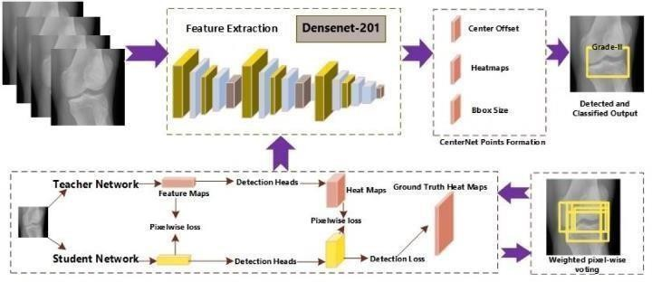.

Fig. 1: Architecture of Proposed Model

## Center Net Architecture

CenterNet is a state-of-the-art object detection framework designed to directly predict object centers and bounding boxes, streamlining the detection process. By leveraging local image details more effectively, this method enhances accuracy in detecting abnormalities within knee joint images. The proposed framework integrates CenterNet with additional strategies to address challenges in medical imaging, such as noise and artifacts. Experimental validation conducted on a publicly available dataset demonstrates the model’s effectiveness, outperforming existing methods in both precision and scalability.

## Base Network

## DenseNet-201 serves as the foundation for the detection framework due to its efficient feature extraction capabilities. Its densely connected layers facilitate the reuse and propagation of information across the network, ensuring robust feature representation. Compared to ResNet, DenseNet offers a more comprehensive approach to capturing intricate details from knee joint images, enabling precise KOA detection.

## Knowledge Distillation

## To improve the scalability and efficiency of the model, a knowledge distillation approach is employed. This technique transfers knowledge from a high-capacity teacher network to a simpler student network, enhancing the latter’s performance while reducing computational overhead. The student network retains high detection accuracy, ensuring the system remains practical for real-world applications.

## Pixel-wise Voting

## The pixel-wise voting mechanism is a critical component of the proposed framework. It involves evaluating each pixel in the input images to determine its likelihood of belonging to an abnormality or the background. By aggregating these pixel-level votes, the framework generates accurate heatmaps that highlight areas of interest within the knee joint. These heatmaps provide valuable visual insights into potential KOA abnormalities, significantly enhancing detection accuracy when combined with the CenterNet architecture.

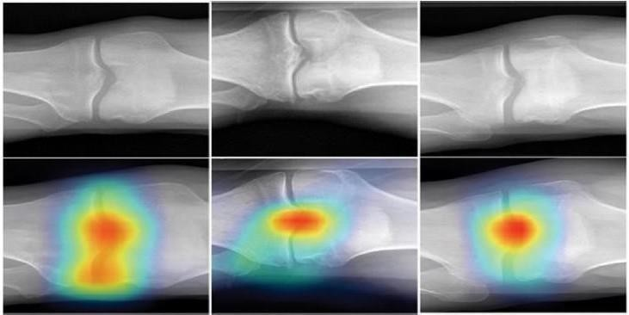

Fig. 2 Samples localization heatmaps

Regions with a higher density of votes correspond to areas with a greater likelihood of KOA abnormalities.

The resulting heatmaps visually represent potential KOA abnormalities within knee joint images, assisting clinicians in precisely locating and classifying these issues. Experimental validation shows that the pixel-wise voting scheme is effective in generating accurate heatmaps for detection. When integrated with the CenterNet architecture, this scheme greatly enhances detection performance, achieving state-of-the-art results in KOA detection.

## 3.5 DenseNet -201

DenseNet-201 and ResNet-101 are both popular convolutional neural network (CNN) architectures used for various computer vision tasks, including knee osteoarthritis (KOA) detection, each with its distinct characteristics and advantages.

DenseNet-201 stands out because of its densely connected blocks, which enable more efficient feature reuse and propagation throughout the network. Unlike ResNet-101, which learns residual mappings between layers in a block, DenseNet-201 creates direct connections between all layers within a block. This dense connectivity ensures that every layer receives input from all the previous layers, allowing for a more effective flow of information and better feature reuse. As a result, DenseNet-201 excels in capturing fine-grained details in knee joint images, making it highly effective for detecting subtle abnormalities in KOA cases.

On the other hand, ResNet-101 also performs well in feature extraction tasks, benefiting from its residual learning framework, which helps to address the vanishing gradient problem in deep networks. However, DenseNet-201's design often offers improved scalability and computational efficiency, allowing it to extract more detailed features with fewer computational resources. While both architectures are well-suited for KOA detection, DenseNet-201 tends to have an edge in terms of information flow and fine feature extraction, making it a more promising choice for precise KOA detection.

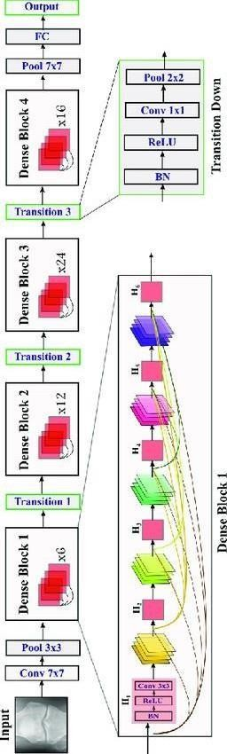This combination of efficient feature reuse and high scalability makes DenseNet-201 a compelling choice for advanced KOA detection tasks.

Fig.3.5 Architecture of DenseNet -201

# 4.Modules and Dataflow

Modules

A "module" denotes a separate part or phase in the implementation process of a model designed to detect Knee OA disease. Each module is essential in the entire process, aiding in the creation of a reliable system for early detection of Knee OA 3 through enhanced CenterNet and Pixel-wise voting techniques.

Data collection.

In this module, the initial step involves gathering data. We are acquiring X-ray images of KOA dataset from kaggle.com. Our dataset includes train and test sets with KL grade 0, 1, 2, 3, or 4 classes. Each class consists of over 1000 images.

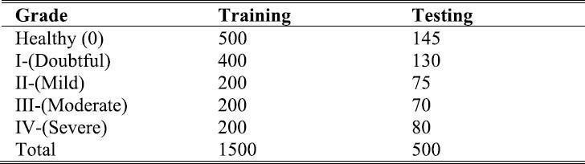

Fig.4 Summary of Mendeley Datset

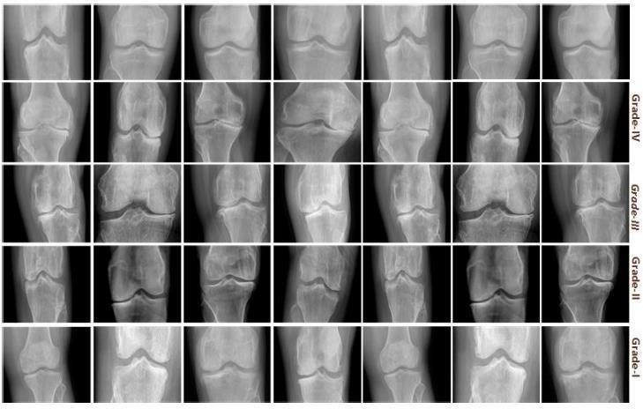

Fig.5 Samples from Dataset

## Data preprocessing

The first step involves gathering knee X-ray images from publicly available datasets such as Kaggle. The dataset comprises training and test samples classified into KL grades 0 to 4, with each grade containing over 1,000 images.

## Feature selection

High-dimensional features are extracted from the knee X-ray images to aid in disease identification and characterization. Regions of Interest (ROIs) are determined using an enhanced CenterNet model with DenseNet-201 as the feature extractor. DenseNet is preferred over ResNet due to its dense connectivity, which improves feature representation.

## Building and Training CenterNet

## The CenterNet model is trained to identify key areas in knee images through two stages—localization and size regression. Gaussian Kernels are applied to generate heatmaps that guide the classifier in recognizing object centers and their dimensions while compensating for potential discretization errors

## Classification of KOA

Once trained, the model predicts the severity of Knee OA by analyzing the output of the deep learning algorithm and categorizing it based on the KL grading scale.

## 4.2 Dataflow

The dataflow process includes a sequence of crucial steps that enhance analysis efficiency. Initially, knee images across various grades, including healthy samples, are gathered. These images then undergo preprocessing, involving tasks such as noise reduction, resizing, and normalization to ensure data consistency.

Once preprocessing is complete, feature extraction techniques identify relevant patterns in the images, such as bone structure characteristics (density, shape, and texture), cartilage thickness, joint space narrowing, and tissue changes indicative of OA progression.

In the training phase, the model learns to distinguish between healthy and OA-affected knees by recognizing extracted features and mapping them to corresponding KL grades. After training, the model is deployed to assess new knee X-ray images, providing diagnostic insights to aid clinicians in early disease detection and intervention planning.

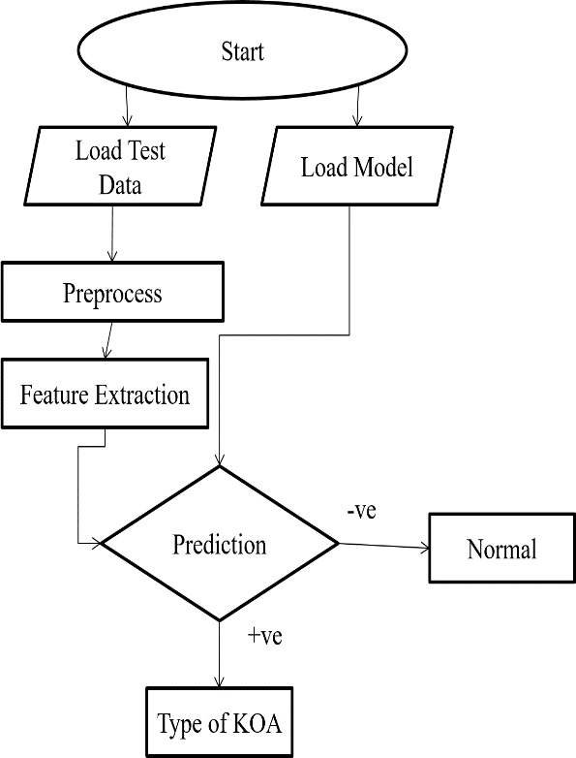

Fig: 4.2 Flow Chart for Detection

# 5. Results

The proposed framework, which combines CenterNet with a pixel-wise voting strategy, demonstrates significant improvements in detecting knee OA abnormalities. Through experimental validation using a publicly available dataset, the model achieved higher accuracy compared to existing approaches. The pixel-wise voting mechanism effectively utilizes localized information, generating precise heatmaps that highlight areas of interest.

By integrating DenseNet-201 for feature extraction, the system captures detailed structural information, enhancing both detection and severity grading of KOA. The experimental results confirm the framework’s ability to outperform state-of-the-art techniques, offering clinicians a reliable tool for early diagnosis and effective treatment planning.

# 6.Conclusion

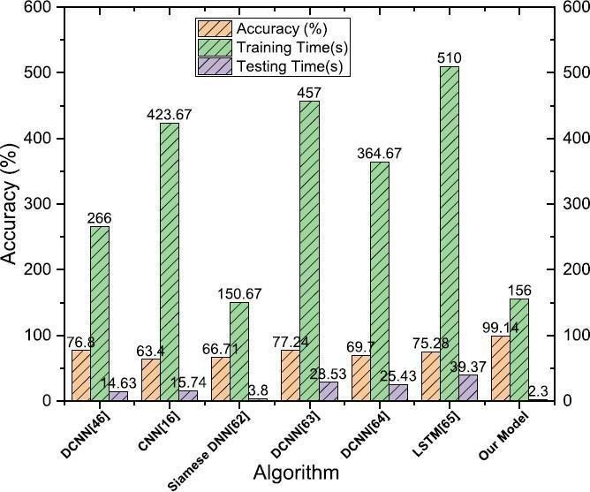

Fig: Accuracy and Algoritham of KOA

This study presents an innovative approach for detecting Knee Osteoarthritis (KOA) by enhancing the CenterNet framework with a pixel-wise voting mechanism. The proposed model demonstrated state-of-the-art accuracy in identifying KOA abnormalities and severity levels from knee joint images. By leveraging DenseNet-201, the framework efficiently extracts and propagates features, enabling precise localization and classification.

The integration of pixel-wise voting significantly improves the detection process, offering clinicians valuable insights for treatment decisions and patient monitoring. The model has wide-ranging applications in orthopedics, particularly in facilitating early intervention and reducing the need for invasive procedures. Future work could focus on expanding the dataset and refining the system to include other musculoskeletal conditions.

# References

1. B. J. Guo, Z. L. Yang, and L. J. Zhang, ‘‘Gadolinium deposition in brain: Current scientific evidence and future perspectives,’’ Frontiers Mol. Neurosci., vol. 11, p. 335, Sep. 2018.
2. L. Shamir, S. M. Ling, W. W. Scott, A. Bos, N. Orlov, T. J. Macura, D. M. Eckley, L. Ferrucci, and I. G. Goldberg, ‘‘Knee X-ray image analysis method for automated detection of osteoarthritis,’’ IEEE Trans. Biomed. Eng., vol. 56, no. 2, pp. 407–415, Feb. 2009.
3. Brahim, R. Jennane, R. Riad, T. Janvier, L. Khedher, H. Toumi, and E. Lespessailles, ‘‘A decision support tool for early detection of knee OsteoArthritis using X-ray imaging and machine learning: Data from the OsteoArthritis initiative,’’ Comput. Med. Imag. Graph., vol. 73, pp. 11–18, Apr. 2019.
4. P. S. Emrani, J. N. Katz, C. L. Kessler, W. M. Reichmann, E. A. Wright, T. E. McAlindon, and E. Losina, ‘‘Joint space narrowing and Kellgren–Lawrence progression in knee osteoarthritis: An analytic literature synthesis,’’ Osteoarthritis Cartilage, vol. 16, no. 8, pp. 873–882, Aug. 2008.
5. M. N. Iqbal, F. R. Haidri, B. Motiani, and A. Mannan, ‘‘Frequency of factors associated with knee osteoarthritis,’’ J. Pakistan Med. Assoc., vol. 61, no. 8, p. 786, 2011.
6. Tiulpin, J. Thevenot, E. Rahtu, P. Lehenkari, and S. Saarakkala, ‘‘Automatic knee osteoarthritis diagnosis from plain radiographs: A deep learning-based approach,’’ Sci. Rep., vol. 8, no. 1, pp. 1–10, Jan. 2018.
7. M. S. M. Swamy and M. S. Holi, ‘‘Knee joint cartilage visualization and quantification in normal and osteoarthritis,’’ in Proc. Int. Conf. Syst. Med. Biol., Dec. 2010, pp. 138–142.
8. P. Dodin, J. Pelletier, J. Martel-Pelletier, and F. Abram, ‘‘Automatic human knee cartilage segmentation from 3-D magnetic resonance images,’’ IEEE Trans. Biomed. Eng., vol. 57, no. 11, pp. 2699–2711, Nov. 2010.
9. N. Kour, S. Gupta, and S. Arora, ‘‘A survey of knee osteoarthritis assessment based on gait,’’ Arch. Comput. Methods Eng., vol. 28, no. 2, pp. 345–385, Mar. 2021.